**Date : 07-08-2020**

1. WAP to display the message "hello" followed by your name on screen.

OUTPUT:

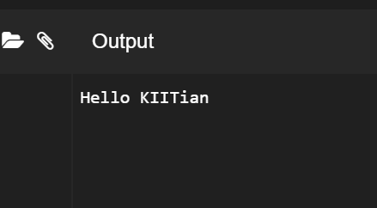

1. Create a class which stores name, roll number and total marks for a student. Input the data for a student and display it.

OUTPUT:

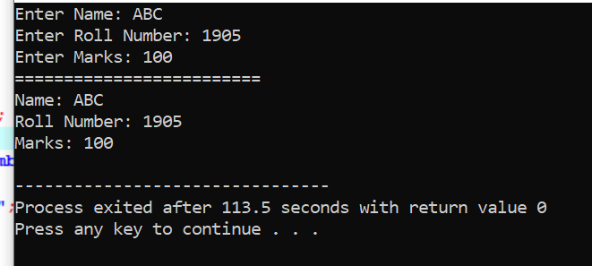

1. Modify the program ii) to store marks in 5 subjects. Calculate the total marks and percentage of a student and display it.

OUTPUT:

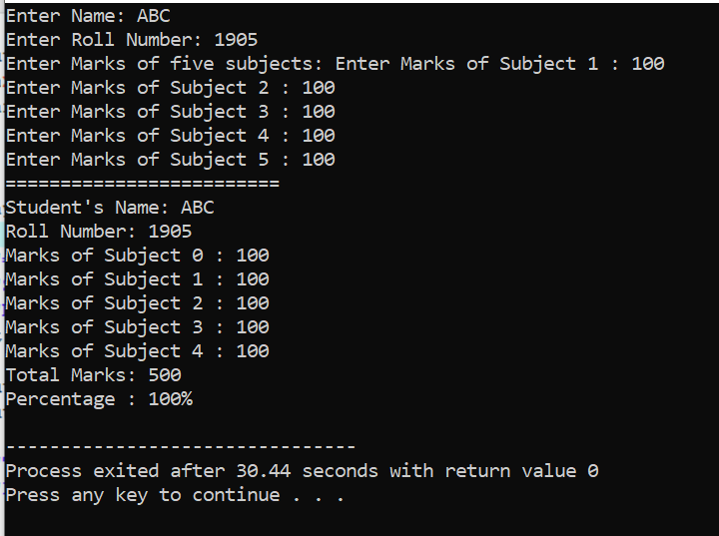

4.Create a class complex which stores real and imaginary part of a complex number. Input 10 complex numbers and display them.

OUTPUT:

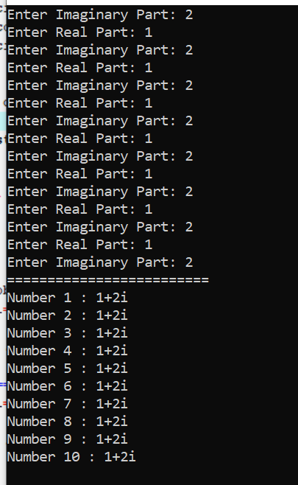

4.Create a class distance which stores a distance in feet and inches. Input 2 distance values

in objects, add them, store the resultant distance in and object and display it.

[Write the above program in two ways.

a) store the resultant distance in the calling object:C3.add(C1,C2)

b) return the resultant object C3=C1.add(C2)

OUTPUT:

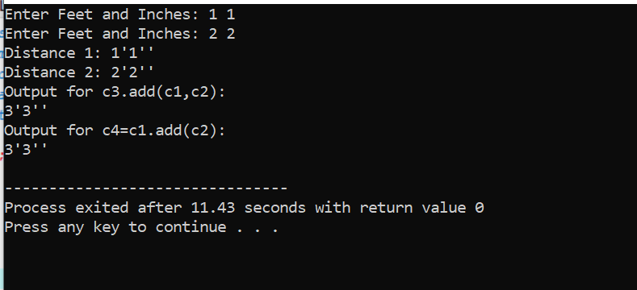

1. Create a class which stores id, name, age and basic salary of an employee. Input data for

n number of employees. Calculate the gross salary of all the employees and display it

along with all other details in a tabular form.

[Gross salary= Basic salary + DA + HRA,

DA = 80% of Basic salary HRA=10%

of Basic salary ]

OUTPUT:

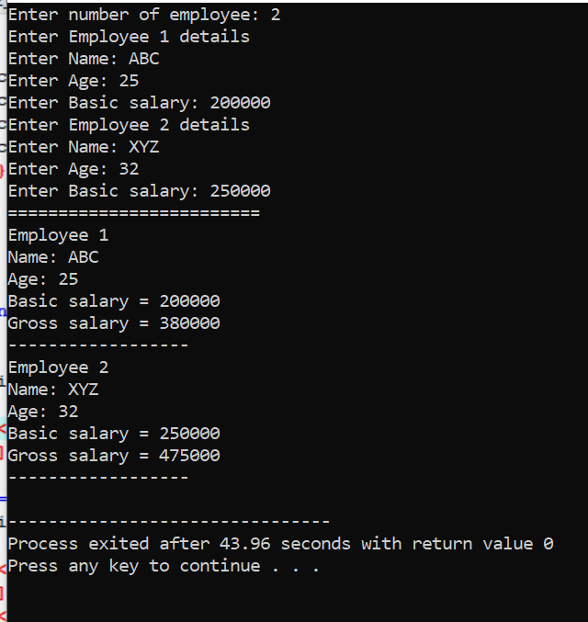

1. Create a class which stores x and y coordinates of a point. Calculate distance between two given points and display it.

OUTPUT:

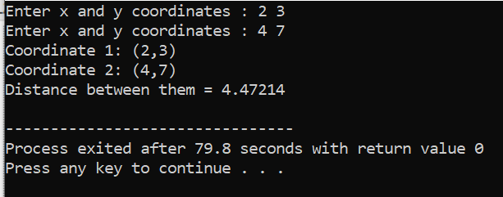

1. nth fibbonacci

OUTPUT :

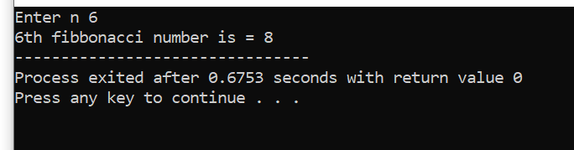

1. Strong Number

OUTPUT :

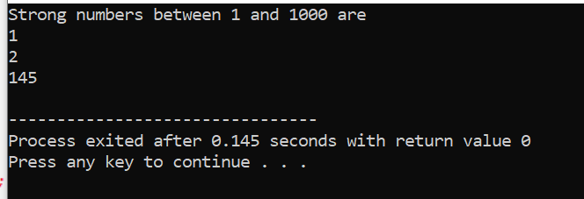

1. Perfect Number

OUTPUT :

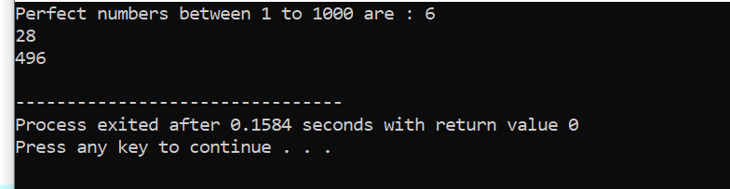

1. Prime Factor

OUTPUT :

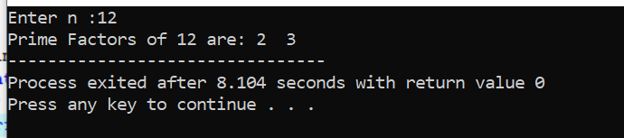

1. Print Bigger Number

OUTPUT :

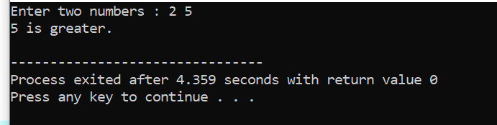

1. Check if divisible by 5 or not without using % operator

OUTPUT :

